 

**CAPSTONE PROJECT REPORT**

**PROJECT TITLE**

THE ROLE OF SCRUM IN AGILE SOFTWARE DEVELOPMENT:

“A COMPREHENSIVE ANALYSIS"

**REPORT SUBMITTED BY:**

**S. Anitha**

**COURSE CODE**: CSA1087

**COURSE NAME:** Software Engineering for Web Development.

**ABSTRACT:**

**The Role of Scrum in Agile Software Development: A Comprehensive Analysis** is a study focused on the Scrum framework's contribution to modern software engineering. The project highlights three core aspects:

1. **Scrum Principles**: An in-depth exploration of Scrum roles, events, and artifacts.
2. **Comparative Analysis**: Insights into how Scrum aligns with and differentiates from other Agile methodologies like Kanban and Extreme Programming.
3. **Practical Simulation**: Development of a task management tool that simulates Scrum processes, including sprints, backlogs, and burndown charts.

Using HTML, CSS, and JavaScript for the front end, and Python with Flask for backend operations, the system employs lightweight local Storage for data persistence. The project follows the Scrum methodology for iterative, user-focused development, showcasing how Scrum enhances collaboration, adaptability, and delivery efficiency in software projects.

**Introduction:**

Agile methodologies have revolutionized software development, emphasizing adaptability, collaboration, and customer satisfaction. Scrum, as a widely adopted Agile framework, has emerged as a cornerstone of iterative and incremental development. This project aims to provide a comprehensive analysis of Scrum’s role in Agile practices, focusing on its implementation in software projects and its benefits in fostering efficient teamwork and project success.

**Background:**

* **Agile Overview**: Originating from the Agile Manifesto, Agile emphasizes iterative development, collaboration, and responsiveness to change.
* **Scrum Overview**: A lightweight framework within Agile, Scrum structures the development process into time-boxed iterations called sprints.
* **Importance of Scrum**: Known for its simplicity and effectiveness, Scrum is used across industries to improve productivity and adaptability.

**Objectives:**

The primary objectives of this project are:

1. **To analyze the core components of the Scrum framework**, including the roles, events, and artifacts, and understand how they contribute to Agile development.
2. **To compare Scrum with other Agile methodologies**, such as Kanban and Extreme Programming, to identify its unique advantages and limitations.
3. **To explore real-world applications of Scrum**, examining its impact on team dynamics, project timelines, and the overall delivery of software.
4. **To design and implement a practical tool or simulation** that mimics Scrum processes, including task management, sprint planning, and progress tracking.
5. **To evaluate the challenges and best practices** in adopting Scrum in diverse software development environments and provide insights for effective implementation.

**Methodology:**

1. **Literature Review**:
   * Study Scrum Guide, Agile Manifesto, and related research.
   * Analyze case studies and industry reports.
2. **System Development**:
   * Design and implement a task management tool simulating Scrum processes.
   * Use Python for backend logic and a simple web interface for user interaction.
3. **Validation**:
   * Test the system for accuracy in task tracking and metric calculations.
   * Compare tool outputs with manual Scrum practices.

**Requirements Gathering:**

* **Functional Requirements**:
  + Maintain product backlog and sprint backlog.
  + Track sprint progress using burndown charts.
  + Assign tasks to team members.
* **Non-Functional Requirements**:
  + User-friendly interface.
  + Scalability for larger projects.
  + Secure data storage.

**Research and Literature Review:**

* Key Topics to Cover:
  + History and evolution of Agile and Scrum.
  + Core principles and components of Scrum (e.g., roles, events, artifacts).
  + Comparison between Scrum and traditional project management approaches.
  + Case studies of successful Scrum implementation in software engineering.
* **Sources to Include:**
  + Agile Manifesto and official Scrum Guide.
  + Books: *"Scrum: The Art of Doing Twice the Work in Half the Time"* by Jeff Sutherland.
  + Research papers, whitepapers, and industry reports.

**What is Scrum?**

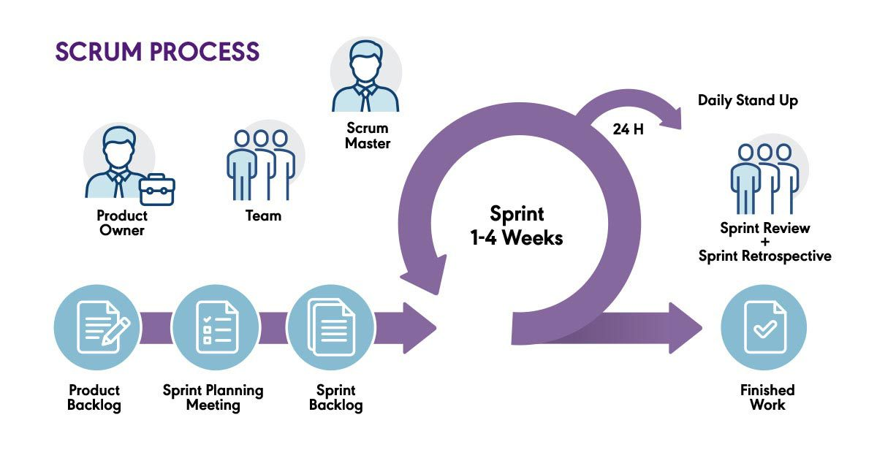

* Scrum is a framework for managing and completing complex projects, primarily in software development. It is part of the Agile methodology, emphasizing iterative progress, collaboration, and flexibility.

**Key Features of Scrum:**

1. **Iterative and Incremental**:
   * Work is divided into small cycles called **sprints**, typically lasting 1–4 weeks.
   * Each sprint delivers a potentially shippable product increment.
2. **Team Collaboration**:
   * Encourages close collaboration among team members, including developers, testers, and product owners.
3. **Empirical Process Control**:
   * Relies on transparency, inspection, and adaptation to make decisions based on observed data rather than predictions.
4. **Lightweight and Flexible**:
   * Provides just enough structure to manage projects while remaining adaptable to change.

**Roles in Scrum:**

1. **Scrum Master**:
   * Facilitates the Scrum process and removes obstacles to the team's progress.
   * Ensures adherence to Scrum principles.
2. **Product Owner**:
   * Represents the customer's interests.
   * Manages the **Product Backlog**, prioritizing features and tasks.
3. **Development Team**:
   * Cross-functional group responsible for designing, developing, and delivering the product increment.

**Role of Scrum in Agile Software:**

**The role of Scrum in Agile software development is to provide a structured framework that facilitates the implementation of Agile principles. Scrum helps teams deliver high-quality software incrementally and iteratively while adapting to changing requirements and fostering collaboration.**

**Key Roles of Scrum in Agile Software Development**

1. Facilitates Iterative Development:
   * Scrum breaks work into smaller, manageable cycles called sprints (1–4 weeks).
   * Each sprint delivers a potentially shippable increment of the software, allowing for frequent feedback and continuous improvement.
2. Encourages Flexibility and Adaptation:
   * By holding regular Sprint Reviews and Retrospectives, Scrum ensures teams adapt to feedback and changes in priorities.
   * Agile projects benefit from Scrum’s ability to incorporate evolving requirements.
3. Improves Transparency:
   * Tools like the Product Backlog and events such as Daily Stand-ups provide visibility into the team's progress.
   * Stakeholders are kept informed, reducing misunderstandings and misaligned expectations.
4. Focuses on Delivering Value:
   * The Product Owner prioritizes tasks in the Product Backlog to focus on high-value features.
   * Scrum’s iterative approach ensures that the most critical aspects of the software are developed first.
5. Supports Continuous Improvement:
   * Scrum fosters a culture of reflection and growth through Sprint Retrospectives, where teams identify areas for improvement.
   * This aligns with Agile’s focus on optimizing processes and outcomes.
6. Drives Accountability and Ownership:
   * The team collectively owns the sprint goals and commits to delivering a Definition of Done (DoD) for each increment.
   * This sense of accountability promotes better quality and efficiency.
7. Simplifies Complex Projects:
   * Scrum’s incremental approach makes large, complex projects more manageable by focusing on one sprint at a time.
   * It reduces the risk of project failure and helps teams respond to challenges dynamically.

**Scrum vs. Agile**

* **Agile** is a broader methodology or mindset emphasizing adaptability, collaboration, and customer satisfaction.
* **Scrum** is a framework within Agile that provides specific roles, events, and artifacts to operationalize these principles.

**Companies using Scrum:**

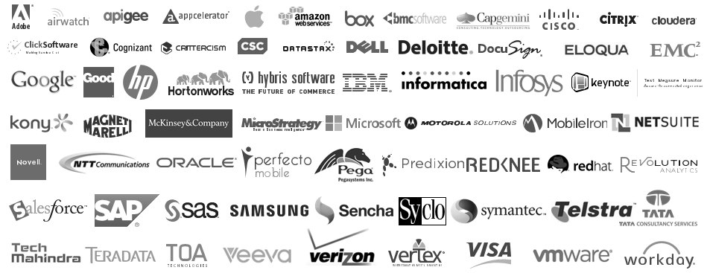

**1. Microsoft**

* **How Scrum is Used**:  
  Microsoft employs Scrum in product development teams, especially for tools like Visual Studio and Azure DevOps. Teams use Scrum to implement iterative development, manage sprints, and deliver frequent updates to customers.
* **Example**:  
  The development of **Azure DevOps** leverages Scrum for continuous integration and delivery, ensuring frequent deployments and rapid feature releases.

**2. Google**

* **How Scrum is Used**:  
  Google uses Scrum across teams working on innovative projects like Android OS, Google Cloud, and Search. It allows them to adapt quickly to changing requirements and maintain their market leadership.
* **Example**:  
  Google’s **Gmail development team** uses Scrum to ensure seamless updates, such as improving UI/UX and introducing new features while maintaining high reliability.

**3. Amazon**

* **How Scrum is Used**:  
  Amazon applies Scrum in its e-commerce and cloud service development (AWS). Scrum helps deliver features iteratively and ensures customer-centricity.
* **Example**:  
  The **Amazon Prime Video team** uses Scrum to manage feature rollouts, test new designs, and optimize streaming services based on user feedback.

**4. Spotify**

* **How Scrum is Used**:  
  Spotify employs an evolved version of Scrum, often referred to as the **Spotify Model**, which emphasizes flexibility. They divide teams into "squads" that operate autonomously using Scrum practices.
* **Example**:  
  Teams at Spotify use Scrum for features like personalized playlists and recommendation engines, ensuring quick iterations based on user behavior.

**5. Tesla**

* **How Scrum is Used**:  
  Tesla uses Scrum in product development, particularly in **software integration for electric vehicles** and features like autopilot. Scrum ensures faster development cycles and continuous innovation.
* **Example**:  
  The **Tesla Autopilot team** uses Scrum to develop and test autonomous driving features, delivering over-the-air software updates iteratively.

**8. Atlassian**

* **How Scrum is Used**:  
  Atlassian not only uses Scrum but also provides tools like **Jira** that are specifically designed for Scrum teams.
* **Example**:  
  The **Jira Software development team** uses Scrum internally to manage updates and enhance features that support Agile project management.

**Why Companies Use Scrum and Its Benefits:**

**Scrum** is widely adopted by companies due to its ability to streamline workflows, improve team collaboration, and adapt quickly to changing project requirements. Below are the key reasons and benefits:

**1. Flexibility and Adaptability**

* **Why**: Modern businesses face rapidly changing market conditions and customer needs. Scrum allows teams to adjust their priorities quickly without derailing the entire project.
* **Benefit**: Teams can incorporate feedback and adapt to changes mid-project, ensuring the final product aligns with customer expectations.

**2. Faster Time-to-Market**

* **Why**: Scrum emphasizes short, time-boxed iterations called **sprints**, each delivering a usable product increment.
* **Benefit**: Companies can release features incrementally, providing value to customers sooner while continuing development.

**3. Enhanced Collaboration**

* **Why**: Scrum fosters collaboration through defined roles (**Scrum Master**, **Product Owner**, **Development Team**) and regular meetings like **Daily Stand-ups**, **Sprint Reviews**, and **Retrospectives**.
* **Benefit**: Improved communication reduces misunderstandings, aligns the team, and creates a shared sense of ownership.

**4. Improved Product Quality**

* **Why**: Scrum integrates continuous testing, feedback loops, and adherence to the **Definition of Done (DoD)**.
* **Benefit**: Issues are identified early, and only high-quality increments are delivered, reducing the risk of major bugs.

**5. Transparency and Visibility**

* **Why**: Tools like the **Product Backlog** and events such as **Daily Stand-ups** provide stakeholders and team members with a clear view of progress and challenges.
* **Benefit**: Increased transparency builds trust among stakeholders and ensures everyone is on the same page.

**6. Better Risk Management**

* **Why**: Scrum delivers work incrementally, allowing risks to be identified and mitigated early.
* **Benefit**: Small, iterative deliveries reduce the chance of complete project failure and allow for course corrections.

**7. Customer-Centric Approach**

* **Why**: Scrum focuses on frequent interaction with stakeholders and prioritizing the most valuable features in the **Product Backlog**.
* **Benefit**: Customers get a product that closely aligns with their needs and can provide feedback during development.

**8. Boosts Team Morale and Productivity**

* **Why**: Scrum empowers teams to self-organize, make decisions, and own their work. Regular retrospectives provide a safe space to voice concerns and suggest improvements.
* **Benefit**: Increased autonomy and regular feedback lead to higher motivation, better teamwork, and improved productivity.

**9. Cost-Effectiveness**

* **Why**: Scrum’s iterative approach allows companies to identify and address inefficiencies early, avoiding expensive last-minute fixes.
* **Benefit**: Focused effort on high-priority tasks ensures better resource utilization and cost savings.

**10. Continuous Improvement**

* **Why**: Scrum emphasizes learning and adapting through **Sprint Retrospectives** and regular feedback cycles.
* **Benefit**: Teams refine their processes and practices over time, resulting in long-term efficiency and effectiveness.

**Benefits, Advantages, Challenges, and Tools Used in Scrum**

**1. Benefits of Scrum:**

Scrum offers significant benefits to organizations, teams, and stakeholders in software development and project management:

**A. Process Efficiency**

* Breaks work into smaller, manageable increments for better focus and tracking.
* Reduces the complexity of large projects.

**B. Product Quality**

* Continuous testing and feedback improve the quality of deliverables.
* Adherence to the **Definition of Done (DoD)** ensures complete and high-standard increments.

**C. Customer Satisfaction**

* Frequent product releases and direct customer involvement ensure alignment with user needs.
* Iterative progress builds trust and satisfaction.

**D. Team Collaboration**

* Encourages teamwork and open communication through **Daily Standups**, **Sprint Planning**, and **Retrospectives**.

**E. Risk Mitigation**

* Regular reviews and short sprints help identify and address risks early.

**2. Advantages of Scrum:**

**A. Flexibility**

* Teams can quickly respond to changes in requirements or priorities, making it suitable for dynamic environments.

**B. Transparency**

* Regular updates and shared backlogs ensure everyone has visibility into project progress.

**C. Time-to-Market**

* Shorter development cycles allow businesses to release products or updates faster.

**D. Continuous Improvement**

* Retrospectives encourage learning from past experiences to improve future performance.

**E. Employee Engagement**

* Empowering teams to self-organize boosts motivation and morale.

**3. Challenges of Scrum:**

While Scrum is powerful, it is not without its challenges:

**A. Requires Discipline**

* Teams need to consistently follow Scrum practices, or the framework’s effectiveness diminishes.

**B. Role Clarity**

* Misunderstanding or overlapping roles (e.g., Scrum Master vs. Product Owner) can lead to confusion.

**C. Scalability**

* Scaling Scrum for large, complex projects across multiple teams can be challenging without proper coordination.

**D. Resistance to Change**

* Teams or stakeholders unfamiliar with Agile may resist adopting Scrum practices.

**E. Lack of Experience**

* Teams new to Scrum may struggle with time-boxing, backlog prioritization, or sprint planning.

**F. Unrealistic Expectations**

* Stakeholders might expect faster delivery without understanding the iterative process.

**4. Tools Used in Scrum:**

Several tools are designed to help teams implement Scrum effectively. Here are some popular ones:

**A. Task Management Tools**

1. **Jira** (by Atlassian)
   * Manages backlogs, sprints, and tracking.
   * Offers Agile boards for visualization.
2. **Trello**
   * Provides a simple Kanban board-style interface for tracking tasks.
   * Ideal for small teams and startups.
3. **Asana**
   * Helps manage tasks, prioritize backlogs, and monitor progress.
4. **ClickUp**
   * Combines task management with collaboration features for teams.

**B. Communication Tools**

1. **Slack**
   * Enables real-time team communication and integration with other tools.
2. **Microsoft Teams**
   * Facilitates collaboration, especially in distributed teams.

**C. Documentation Tools**

1. **Confluence**
   * Stores project documentation, meeting notes, and sprint retrospectives.
2. **Google Workspace**
   * Shared drives and collaborative documents for transparent communication.

**D. Reporting and Metrics Tools**

1. **Burndown Chart Tools (e.g., Jira)**
   * Visualize work progress and remaining tasks in a sprint.
2. **Miro or MURAL**
   * Collaborative whiteboards for sprint planning and retrospectives.

**E. CI/CD Tools (for Development Teams using Scrum):**

1. **GitHub Actions**
   * Automates integration and deployment in development workflows.
2. **Jenkins**
   * Facilitates automated testing and builds during sprints.

**Conclusion:**

* Scrum is a vital framework in Agile software development, enabling teams to deliver high-quality products through iterative processes, enhanced collaboration, and adaptability. By fostering transparency and continuous improvement, Scrum helps organizations meet evolving customer needs efficiently. Despite its challenges, proper implementation and supportive tools make Scrum an indispensable approach for managing complex projects and driving innovation in modern software development.

BOOK REFERENCES:

1. **"**User Stories Applied: For Agile Software Development"

* Author: Mike Cohn

2. "Agile Software Development with Scrum"

* Authors: Ken Schwaber and Mike Beedle

3. "Essential Scrum: A Practical Guide to the Most Popular Agile Process"

* Author: Kenneth S. Rubin

4**.** "Scrum Mastery: From Good to Great Servant Leadership"

* Author: Geoff Watts